**MAE 3403 Project**

**Selection of Team Members and Project Topic**

Due Wed, Oct 23rd, at the beginning of class – Turned in on PHYSICAL PAPER, not scanned

Your team will choose one of the following two options: Dr. Delahoussaye’s standard class project, or a custom project, supervised and graded by another faculty member. Should you choose the second option, you will need to submit a project proposal for Dr. Delahoussaye’s approval.

# Dr. Delahoussaye’s Standard Project – Pipe network analysis and design

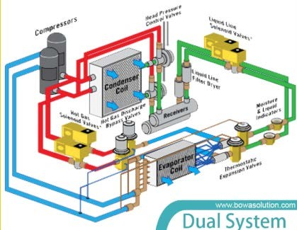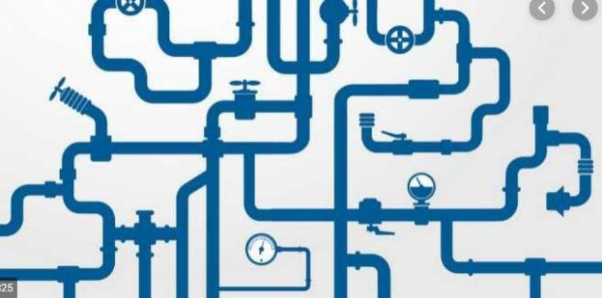

Write a Python program to perform – Pipe Network Analysis and Design. The preliminary requirements for the program are:

1. It will have a well laid out graphical user interface (GUI).
2. It will read the pipe network data from a keyword based text file.
3. It will have an interactive text editor that allows user modifications to the pipe network.
4. It will be able to analyze the flows and pressures in the network.
5. It will be ***possibly*** able to choose optimal pipe diameters
6. It will be able to select the pump
7. It will be able to draw a nicely labeled diagram of the network
8. It will be able to produce a nicely laid out report file

# A Custom Project, Supervised and Graded by Another Faculty Member

With the assistance and agreement of another faculty member, choose a programming project of mutual interest to the team and the faculty. The program should be a significant amount of effort (300 to 500 lines of code), and solve a significant problem. This type of project works best when the faculty has a real software need, which the team can meet.

Because projects of this type usually have ***technical content*** where Dr. Delahoussaye has no expertise, the supervising faculty must agree to evaluate and submit a grade to Dr. Delahoussaye, for the work performed by the student team. If you choose this option, you will also need to submit a project proposal as described on the next page.

***Our team has chosen***: ____ Standard Project ____ A custom project (must complete Custom Project Proposal)

***Names of Team Members: (3 people per team): Signatures of Team Members:***

|  |  |  |
| --- | --- | --- |
|  | Names | Signature |
| 1 | Trevor Clark |  |
| 2 | Diego Colón |  |
| 3 | Aaron Corona |  |

# Custom Project Proposal

***Names of Team Members*** (3 people per team):

1. Trevor Clark

2. Diego Colón

3. Aaron Corona

***Name of Supervising Faculty***:

***Project Title***: Efficiency Comparison of Path Planning Algorithms

***General Subject area*** (structures, thermal fluids, dynamics, etc.):

***Detailed Problem Description****: In this space, describe in detail the problem or problems your program will solve. Include any important diagrams, figures etc., which explain the problem. Also provide details as to the type of input the program will receive, and output the program will generate e.g., a table of numbers, a plot, animated graphics, etc.*

There are many different path planning algorithms for mobile robotics. They range deterministic to probabilistic, discrete or continuous, and many other categories. The objective of this project is to compare the efficiency of different path planning algorithms. The efficiency will be measured as the ratio of the displacement to the distance covered by the path. The algorithms to be tested would include: A star, Dijkstra, RRT, RRT*, Potential Fields and Dynamic Windows. They will receive 3 arguments: initial position, final position and obstacles. With these inputs they will generate a path that complies with the kinematics of the mobile base and compare their efficiencies. In the end it will show graphs of the different paths overlaid on the map with obstacles, and a graph showing efficiency as a function of the path length to identify where the algorithms start diverging. This project can be applied to other platforms other than just mobile robots. The intent is that by creating it for mobile robots it can be used for other platforms in their configuration spaces so long as the kinematics for the platform are given

***Solution Process****: In this space, describe the process and procedures your program will use to arrive at the solution. Here you can include a preliminary flow chart or other figures, diagrams, equations, etc. If you are not exactly sure of the process, write down what you do know of the process and speculate about any missing parts of the solution. You should include the main tasks along with their inputs and outputs.*

|  |  |
| --- | --- |
| The main code will follow a flow chart like this. The initialization will consist of two classes that holds the information of the platform (kinematics, initial and final conditions) and of the world (obstacles). This step is followed by the path planning where the platform object gets passed into the algorithm and a path is created as a class that holds the path coordinates and path efficiency. Finally the information will be compared in graphs. |  |

***Math Background****: In this space, describe the Mathematics to be used to solve the problem.*

This project will have a heavy use of linear algebra, calculus and some differential equations. The linear algebra will be used to write the equations of motions for the different platforms, the calculus will be required for the Potential Fields and Dynamic Windows and the differential equations will be needed to merge both areas together.

*Signature of the supervising Faculty______________________________, certifying that in their opinion, the problem should require a significant amount of effort (300 to 500 estimated lines of code), and that they agree to evaluate the team’s work and submit a project grade to Dr. Delahoussaye.*